To compute the curve, we need to build a series of simultaneous equations that will give the coefficients of the curve.

Through the magic of advanced mathematics, the equations are as follows, where:
- m is the degree of the polynomial that we wish to use
- a_{i} are the coefficients of the least-squares equation – they are the values that we wish to find
- N is the number of points
- x_{i} and y_{i} are the data points we were given
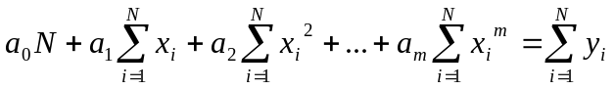
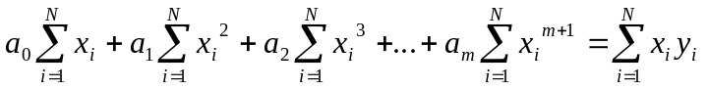
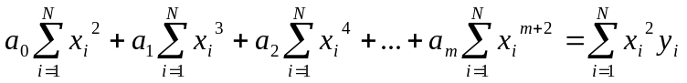
…
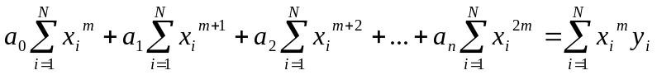

Note the pattern which is developing - with a degree of m, our last equation will start with the sum of the x values to the m^{th} power and equal the sum of the values to the m^{th} power times the y values, etc.

These equations represent the m+1 simultaneous equations containing the m+1 unknown coefficients for the curve that will approximate the experimental data points.

